Chapter 3
Two Dimensional Drawing Algorithms

- Scan Converting a Point
- Scan Converting a Straight Line: DDA Line Algorithm, Bresenham's Line Algorithm
- Scan Converting a Circle and an Ellipse: Mid-Point Circle and Ellipse Algorithm,
- scan line algorithm, flood fill and boundary fill algorithm

Scan Conversion
- The basic building block of pictures are referred to as output primitives.
- Output primitives are the geometric structures that can be used the describe the shape and color of the objects.
- They include character, strings and geometric entities such as points, straight lines, circle, polygons etc. (Point and Lines are the most basic components of Picture).
- In a raster display system, a picture is specified by set of intensities for the pixel positions in the display.
- We generate images by turning the pixels ON or OFF, so it is necessary to represent an object(continuous) as a collection of discrete pixels.
- Hence the process of determining the appropriate pixels for representing a picture (or graphics object) is called rasterization.
- The process of conversion of the rasterized picture i.e. picture definition,stored in the frame buffer into a set of pixel intensity values for the rigid display pattern is called scan conversion. This is done by display processor.

Point Scan Conversion
- A mathematical point (x,y) where x and y are real numbers within an image area, needs to be scan converted to a pixel at location (x’, y’).
- So point plotting is accomplished by converting a single coordinate position into appropriate operation for the output device in use. Example: For CRT, Electron beam can be turned on for illuminate the screen phosphor or off at the selected location on the display technology.
- Now the question is how the electron beam is positioned depends upon the display technology?
- In case of raster system, a point can be plotted by setting the bit value corresponding to a specified screen position within the frame buffer to one. This is done by simply turning on the electron beam at that point.
- But in case of random system, it stores the point plotting instruction in the display list file. The coordinate values in this file are converted to deflection voltage that position the electron beam at the screen location to be plotted.
- In raster system, line drawing is accomplished by calculating intermediate positions along the line path between two specified points. Then the output device is directed to fill in these positions between endpoints.
- But in case of random system (example: vector pen plotter), line drawing is accomplished by retrieving line drawing commands from the display list.
- Scan lines are numbered consecutively from 0, starting the bottom of the screen; the pixel columns are numbered from o, from left to right across each scan line.
Scan line number
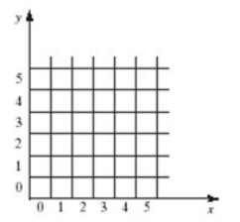Pixel Column number

Line Scan Conversion
- The Cartesian slope-intercept equation for a straight line is
y = m.x+c……………..i)
where, m=slope of line and c= y intercept

- When the two endpoints of a line are given as (x1, y1) and (x2, y2) as shown in figure below, we can determine the value of slope m and intercept c with the following calculation
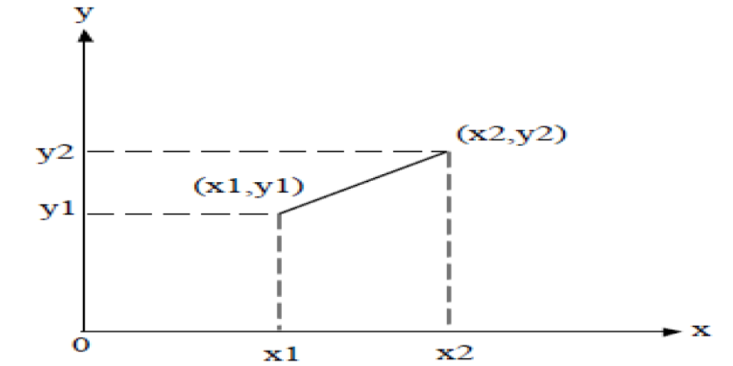
Fig: Line path between end point position (x1,y1) and (x2, y2)

m= (y2-y1)/(x2-x1)……………………………………ii)

Now, for any point (x_{k}, y_{k),} i becomes,
y_{k} = m.x_{k} + c……………………………………………………..iii)

Again for any point (x_{k+1,} y_{k+1}), i become
y_{k+1} = m . x_{k+1} + c ………………………………………………..iv)

Subtraction iii from iv we get,
y_{k+1} –y_{k} = m. x_{k+1} +c – m.x_{k} – c

y_{k+1} – y_{k} = m. (x_{k+1} – x_{k})
i.e. Δy = mΔx, where, Δy and Δx are small increment in x and y respectivey.
Therefore, m= Δy / Δx ……………………………………………v)

- The above equation v, forms the basis for determining the intermediate pixel’s position (i.e. deflection voltage in analog device like CRT).

- When the value of m is calculated using equation ii, test for three cases can be performed as
Case I: For |m| < 1,
  - △x can be set to small increment (Generally 1) and the corresponding △y calculated from equation (v). (△x range is high)
Case II: For |m| > 1,
  - △y can be set to small increment (Generally 1) and the corresponding △x calculated from equation (v).(△y range is high)
Case III: For |m| = 1,
  - △y=△x, x and y pixels both are equal.
- In each case, a smooth line with slop m is generated between the specified points

DDA Algorithm
- It is a scan conversion line algorithm based on calculation either △x or △y using equation m=△y/△x.
- We sample the line at unit interval in one direction (X if △x is greater than △y otherwise in y direction) and determine the corresponding integer values nearest the line path for the other coordinate.
Algorithm
Consider a line with positive slope as shown in the figure below
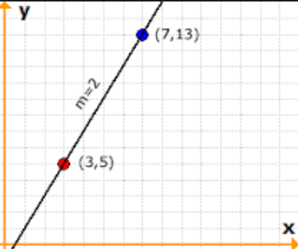
The equation of the line is given,
Y = m.x+b ………………….(i)
m = (y2-y1)/(x2-x1) ………………….(ii)
For any interval △x, corresponding interval is given by △y = m.△x.
Case I:
If |m| ≤ 1, we sample at unit x interval i.e △x = 1.
x_{k+1} = x_{k}+1 ..…..……………..(iii)
Then we compute each successive y-values, by setting △y = m (since, m=△y/△x and △x=1).
So, y_{k+1} = y_{k} + m ……………………..(iv)
The calculated y value must be rounded to the nearest integer

Case II:
If |m| > 1, we sample at unit y-interval i.e △y = 1 and compute each successive x-values.
y_{k+1} = y_{k}+ 1…………….(v)
Therefore, 1 = m.△x, and △x = 1/m (since, m=△y/△x and △y=1).
x_{k+1} = x_{k}+ 1/m… ……..(vi)

- The above equations are under the assumption that lines are to be processed from left endpoints (x_{k}, y_{k}) to right endpoints (x_{k+1}, y_{k+1}). If the line is to be processed from right to left i.e. starting end point is at the right then,
△x= -1
- For |m|≤1, x_{k+1} =x_{k} – 1 and y_{k+1} = y_{k} – m ……………vii)

And for slope greater than 1, △x= -1

- For |m|>1, y_{i+1} = Y_{k} -1, and X_{k+1} = x_{k} – (1/m) …………….viii)

- The obtained equations also can be used to calculate the pixel position along a line with negative slope as below.
  - If |m|<1 and the start end point is left, we set △x=1, and calculate the Y value as in case i.
  - If |m|<1 and the start end point is right, we set △x=-1, and calculate the Y value as in equation vii.
  - If|m|>1 and start end point is left, we set △y=1`, and calculate the Y value as in case ii.
  - If|m|>1 and start end point is right, we set △y=-1`, and calculate the Y value as in equation vii.
Advantage of DDA
- It is simple to understand.
- It is faster method than direct use of line equation y=mx+c.(Removes multiplication operation and only involve increments operation of x or y direction)
- It requires no special skills for implementation
Disadvantages of DDA
- A floating point addition is still needed in determining each successive point which is time consuming.
- The accumulation of round off error in successive addition of the floating point increments may cause the calculated pixel position to drift away from the true line path for long line segment.

Pseudo Code
DDA Algorithm is given below:
procedure DDA( x1, y1, x2, y2: integer);
var
dx, dy, steps: integer;
x_inc, y_inc, x, y: real;
begin
dx := x2 - x1; dy := y2 - y1;
if abs(dx) > abs(dy) then
steps := abs(dx); {steps is larger of dx}
else
steps := abs(dy);
x_inc := dx/steps; y_inc := dy/steps;
{either x_inc or y_inc = 1.0, the other is the slope}
x:=x1; y:=y1;
set_pixel(round(x), round(y));
for i := 1 to steps do
begin
x := x + x_inc;
y := y + y_inc;
set_pixel(round(x), round(y));
end;
end

Numerical Examples
- Consider a line from (2,1) to (8,3). Using simple DDA algorithm, rasterize this line.
Solution:
Given Starting Point :(x1, y1)= (2,1) and Ending Point: (x2,y2) = (8,3)
Now Slope m=(y2-y1)/(x2-x1)= (3-1)/(8-2) =(1/3) = 0.333
Since |m|<1, From DDA algorithm we have
X_{k+1} = X_{k}+ 1
Y_{k+1} = Y_{k} + (M)

X | Y | X-Plot | Y-Plot | (X,Y)
2 | 1 | 2 | 1 | (2,1)
3 | 1.33 | 3 | 1 | (3,1)
4 | 1.66 | 4 | 2 | (4,2)
5 | 1.993 | 5 | 2 | (5,2)
6 | 2,326 | 6 | 2 | (6,2)
7 | 2.659 | 7 | 3 | (7,3)
8 | 2.999 | 8 | 3 | (8,3)
- Digitized the line with end points (0,0) and (4,5) using DDA.
Given Starting Point :(x1, y1)= (0,0) and Ending Point: (x2,y2) = (4,5)
Now Slope m=(y2-y1)/(x2-x1)= (5-0)/(5-0) =(5/4) = 1.25
Since |m|>1, From DDA algorithm we have
y_{k+1} = y_{k}+ 1
x_{k+1} = x_{k} + (1/m)
X | Y | X-Plot | Y-Plot | (X,Y)
0 | 0 | 0 | 0 | (0,0)
0.8 | 1 | 1 | 1 | (1,1)
1.6 | 2 | 2 | 2 | (2,2)
2.4 | 3 | 2 | 3 | (2,3)
3.2 | 4 | 3 | 4 | (3,4)
4 | 5 | 4 | 5 | (4,5)

- Digitized the line with end points (3,7) and (8,3) using DDA.
Given Starting Point :(x1, y1)= (3,7) and Ending Point: (x2,y2) = (8,3)
Now Slope m=(y2-y1)/(x2-x1)= (3-7)/(8-3) =(-4/5) = -0.8
Since |m|<1, From DDA algorithm we have
X_{k+1} = X_{k}+ 1
Y_{k+1} = Y_{k} + (M)

X | Y | X-Plot | Y-Plot | (X,Y)
3 | 7 | 3 | 7 | (3,7)
4 | 7-0.8=6.2 | 4 | 6 | (4,6)
5 | 5.4 | 5 | 5 | (5,5)
6 | 4.6 | 6 | 5 | (6,5)
7 | 3.8 | 7 | 4 | (7,4)
8 | 3 | 8 | 3 | (8,3)

- Consider a line from (0,0) to (5,5). Using simple DDA algorithm, rasterize this line.
Solution:
Given Starting Point :(x1, y1)= (0,0) and Ending Point: (x2,y2) = (5,5)
Now Slope m=(y2-y1)/(x2-x1)= (5-0)/(5-0) =(/55) = 1
Since |m|<=1, From DDA algorithm we have
X_{k+1} = X_{k}+ 1
Y_{k+1} = Y_{k} + (M)
X | Y | X-Plot | Y-Plot | (X,Y)
0 | 0 | 0 | 0 | (0,0)
1 | 1 | 1 | 1 | (1,2)
2 | 2 | 2 | 2 | (2,2)
3 | 3 | 3 | 3 | (3,3)
4 | 4 | 4 | 4 | (4,4)
5 | 5 | 5 | 5 | (5,5)

Bresenham’s Line Algorithm
- An accurate (avoids round off as in DDA) and efficient raster line generating algorithm, developed by Bresenham, scan converts lines using only incremental integer calculations that can be adapted to display circles and other curves.
- It introduces the integer decision parameter to select the next appropriate pixel point.
- Advantage of BLA over DDA
- In DDA algorithm, each successive point is computed in floating point, so it requires more time and more memory space but in BLA each successive point is calculated in integer value or whole number. So it requires less time and less memory space.
- In DDA, since the calculated point value is floating point number, it should be rounded at the end of calculation but in BLA it doesn’t need to round, so there is no accumulation of rounding error.
- Due to rounding error, the line drawn by DDA algorithm is not accurate, while BLA is accurate.
- DDA algorithm can’t be used in other application except line drawing but BLA can be implemented in other application such as drawing circle, ellipse and other curves.

Bresenham's Algorithm for 0<|m|≤1:
- Step 1: Input the line endpoints and store the left endpoint in (x0, y0).
- Step 2: Load (x0, y0) in to the frame buffer, i.e., plot the first point.
- Step 3: Calculate constants Δx, Δy, 2Δy -2Δx, and obtain the initial decision parameter as;
p0 = 2Δy – Δx
- Step 4: At each xk along the line, starting at k = 0, perform the following test;
- If pk < 0
Plot pixel(xk+1, yk), and
Set pk+1 = pk +2Δy
- Otherwise,
Plot pixel(xk+1, yk+1), and
Set p_{k+1} = p_{k} + 2Δy - 2Δx
- Step 5: Repeat step 4, Δx times.
- Step 6: End.

Bresenham’s Algorithm for |m|>1
- Step 1: Input the line endpoints and store the left endpoint in (x0, y0).
- Step 2: Load (x0, y0) in to the frame buffer, i.e., plot the first point.
- Step 3: Calculate constants Δx, Δy, 2Δx-2Δy, and obtain the initial decision parameter as;
p0 = 2Δx – Δy
- Step 4: At each yk along the line, starting at k = 0, perform the following test;
- If pk < 0
Plot pixel(x_{k}, y_{k+1}), and
Set p_{k+1} = pk +2Δx
- Otherwise,
  - Plot pixel(x_{k+1}, y_{k+1}), and
  - Set p_{k+1} = p_{k} + 2Δx - 2Δy
- Step 5: Repeat step 4, Δy times.
- Step 6: End.

Questions:
- Apply Bresenham’s algorithm to draw a line from (20,15) and end point is (30,30)
Solution
Starting Point (x₀,y₀) = (20, 15) Ending Point (x_{n}, y_{n}) = (30, 30) such that scanning takes place from left to right
Slope m = (30-15)/ ( 30-20) = 1.5 i.e. |M|>1
Here: Δx= 30-20 = 10 Δy= 30-15 = 15 2Δx = 2 * 10 = 20 2Δy = 2 * 15 = 30

Now from Bresenhams Algorithm for |M|>1, and scanning from left to right
Initial Decision Parameter: P₀ ₌ p0 = 2Δx – Δy
if(p_{k}<0) then
X_{k+1} = X_{k} and
Y_{k+1} = Y_{k}+1 and
P_{k+1} = P_{k} + 2Δx
otherwise
X_{k+1} = X_{k+1} and
Y_{k+1} = Y_{k}+1and
P_{k+1} = P_{k} + 2Δx - 2Δy
Repeat Δy times

K | P_{k} | (X_{k+1}, Y_{k+1}
0 | 5 | (21,16)
1 | -5 | (21,17)
2 | 15 | (22,18)
3 | 5 | (23,19)
4 | -5 | (23,20)
5 | 15 | (24,21)
6 | 5 | (25,22)
7 | -5 | (25,23)
8 | 15 | (26,24)
9 | 5 | (27,25)
10 | -5 | (27,26)
11 | 15 | (28,27)
12 | 5 | (29,28)
13 | -5 | (29,29)
14 | 15 | (30,30)

Therefore the digitized coordinates are (x0, y0) = (20,15), (x1, y1) = (21,16),………..(x15,y15) = (30,30)

- Apply Bresenham’s algorithm to draw a line from (-3,0) and end point is (4,4)
Solution
Starting Point (x0,y0) = (-3, 0) Ending Point (x_{n}, y_{n}) = (4,4) such that scanning takes place from left to right
Slope m = (4-0)/ ( 4+3) = 4/5 = 0.57 i.e. |M|<1
Here: Δx= 4 + 3 = 7 Δy= 4 - 0 = 4 2Δx = 2 * 7 = 14 2Δy = 2 * 4 = 8

Now from Bresenhams Algorithm for |M|<1, and scanning from left to right
Initial Decision Parameter: P₀ = 2Δy – Δx
if(p_{k}<0) then
X_{k+1} = X_{k} + 1 and
Y_{k+1} = Y_{k} and
P_{k+1} = P_{k} + 2Δy
otherwise
X_{k+1} = X_{k}+1 and
Y_{k+1} = Y_{k+1} and
P_{k+1} = P_{k} + 2Δy - 2Δx

Repeat Δx times
K | P_{k} | (X_{k+1}, Y_{k+1}
0 | 1 | (-2,1)
1 | -5 | (-1,1)
2 | 3 | (0,2)
3 | -3 | (1,2)
4 | 5 | (2,3)
5 | -1 | (3,3)
6 | 7 | (4,4)
Therefore the digitized coordinates are (x0, y0) = (-3, 0), (x1, y1) = (-2, 1),………..(x7,y7) = (4,4)

Note: If the initial point for a line with positive slope is right endpoint, then both X any Y decreases but for negative slope, the procedure is similar, except that now one coordinate decreases as the other increases.

Midpoint Circle Generating algorithm
- Since a circle is a symmetrical figure, midpoint circle generating algorithm take this advantage of symmetry property to plot right points for each value that the algorithm calculates.
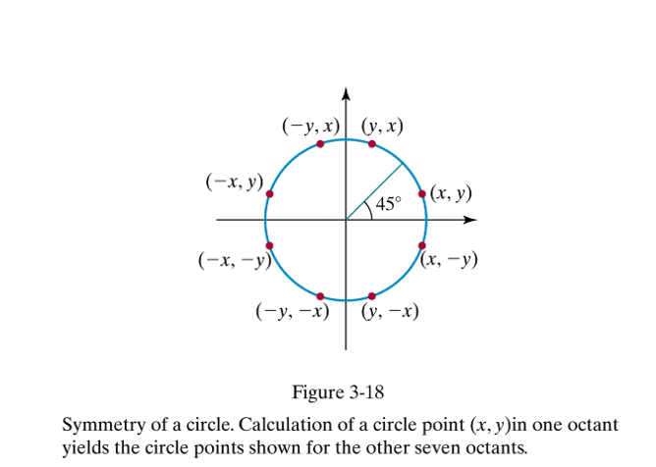
- Eight-way symmetry is used by reflecting each calculated point around each 45 degree axis.
- Suppose a calculated point is (x,y), then we can obtain eight different point as:
(x,y), (x,-y), (-x,y), (-x,-y), (y,x), (-y,x), (y,-x), (-y,-x)
- So using this symmetry principal, we can reduce the amount of computation.

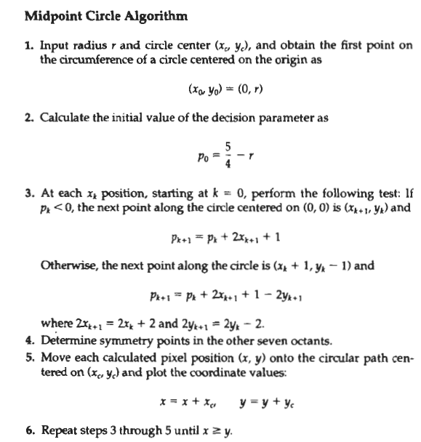

//See your class note for detail derivation of Decision Parameter

Numerical
- Digitized the circle with radius 10
Solution:
Initial Point = (Xo,Yo)= (o,r) = (0,10) and origin = (0,0)
Initial decision parameter (p₀) = 1 – r = 1 – 10 = -9
From midpoint circle algorithm we have
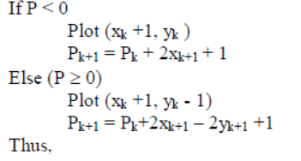
Now, the successive decision parameter values and position along the circle path are determined as follow.

K | P_{k} | X_{k+1} | Y_{K+1} | (X_{K+1,} Y_{k=1})
0 | -9 | 1 | 10 | (1,10)
1 | -9*2*1+1=-6 | 2 | 10 | (2,10)
2 | -6 + 2*2+1=-1 | 3 | 10 | (3,10)
3 | -1 + 2 * 3 + 1 = 6 | 4 | 9 | (4,9)
4 | 6 + 2 * 4 – 2 * 9 + 1 =-3 | 5 | 9 | (5,9)
5 | -3 + 2 * 5 + 1= 8 | 6 | 8 | (6,8)
6 | 8 + 2 * 6 – 2 * 8 + 1 = 6 | 7 | 7 | (7,7)
7 | 5+ 2 * 7-2 * 7 + 1 =5 | 8 | 6 | [stop and discard this point since x>y

Hence, the digitized coordinates for circle in first octant are (x0,y0) = (0, 10), (x1,y1) = (1,10)…..(x7,y7)=(7,7).

Note: For each calculated point we need to apply symmetry principle to obtain eight different coordinates one for each of the eight different octants.

- Digitized a circle with radius r=12 and centered at (250,300)
Solution:
Note: When center is not origin, we first calculate the octants points of the circle in the same way as the center at origin then add the given circle center on each calculated pixels.
Here, Initial Point (x0,y0) (0,r) = (0,12) and origin=(0,0)
Initial decision parameter (p₀) = 1 – 12 = 1 – 12 = -11
From midpoint circle algorithm we have
Now, the successive decision parameter values and position along the circle path are determined as follow.
K | P_{k} | X_{k+1} | Y_{k+1} | (X_{k+1}, Y_{k+1}) _{a}t (0,0) | (X_{k+1}, Y_{k+1}) _{a}t (250,300)
0 | -11 | 1 | 12 | (1,12) | (250+1, 300+12)=(251,312)
1 | -11 + 2* 1 + 1 = -8 | 2 | 12 | (2,12) | (250+2,300+12) =(252,312)
2 | -8 + 2 * 2 + 1 = -3 | 3 | 12 | (3,12) | (250+3,300+12) =(253,312)
3 | -3 + 2 * 3 + 1=4 | 4 | 11 | (4,11) | (250+4,300+11) =(254,311)
4 | 4 + 2 * 3 – 2 * 11 + 1= -9 | 5 | 11 | (5,11) | (250+5,300+11) =(255,311)
5 | -9 + 2 * 5 + 1 = 2 | 6 | 10 | (6,10) | (250+6,300+10) =(256,310)
6 | 2 + 2*6 – 2* 10 + 1 = -5 | 7 | 10 | (7,10) | (250+7,300+10) =(257,310)
7 | -5 + 2 * 7 + 1 = 10 | 8 | 9 | (8,9) | (250+8,300+9) =(258,309)
8 | 10+ 16 – 18 + 1= 9 | 9 | 8 | (Discard and stop since X>Y)

Therefore the digitized coordinates are (Xo,Yo) = (250+0, 300+12) = (250,312), (X1,Y1)= (251,312)……
(X8,Y8)= (258,312)

Midpoint Ellipse Algorithm

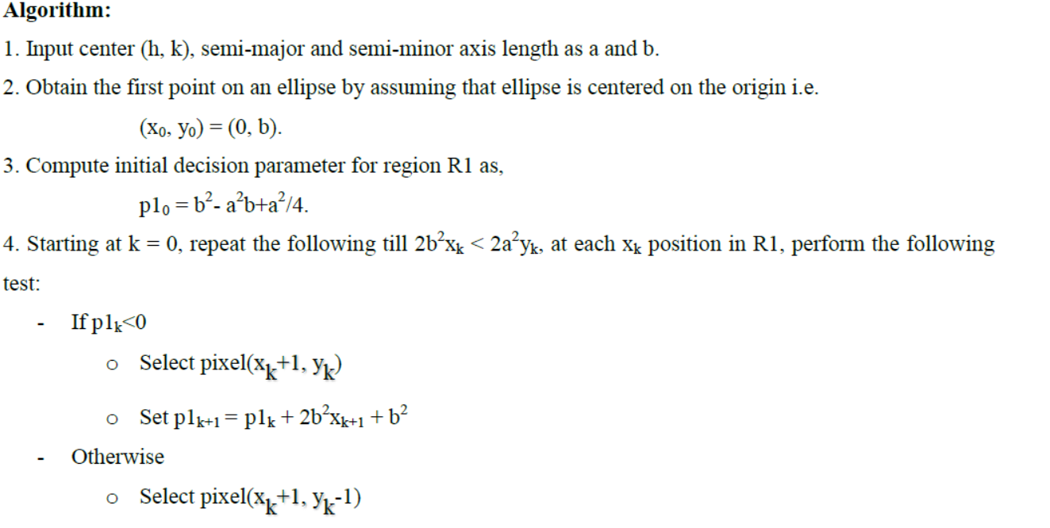
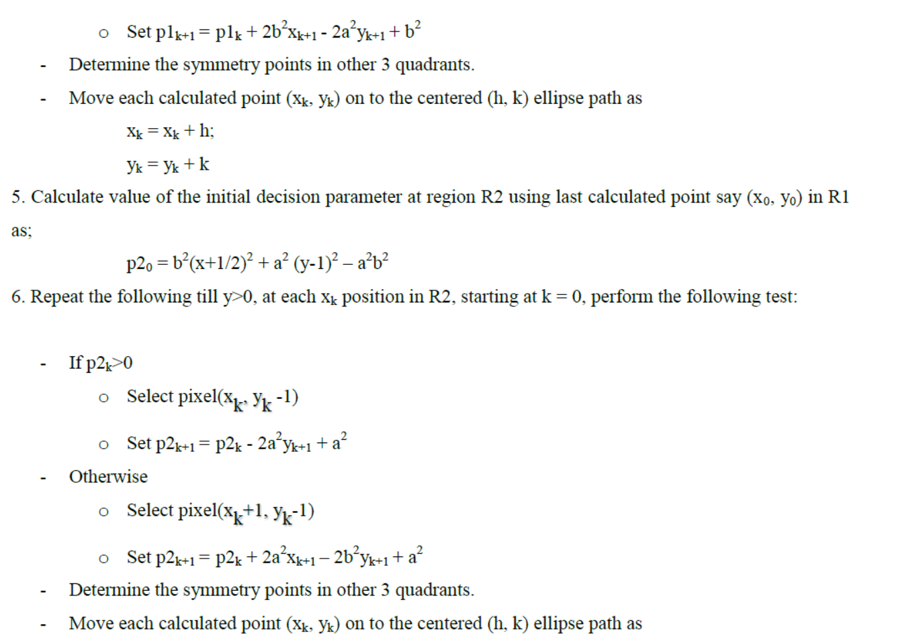

//see class notes for derivation of Decision Parameter

Numerical
- The input ellipse parameters are r_{x} = 8 and r_{y} = 6. Using midpoint method, rasterize this ellipse.
Solution:
Given r_{x} = 8 and r_{y}= 6
For Region 1
The initial point for the ellipse on the origin (xo, yo) = (0, r_{y}) = (0,6)
Calculation the initial decision parameter
P₁₀ = r²_{y + (} r²_{x} / 4) – r_{y}r²_{x}
= ₆²₊ (8² / 4) - 6 * (8)²
= -332
From midpoint algorithm, for Region 1 we know,
If(P_{k}<0) then
X_{k+1} = X_{k} + 1
Y_{k+1} = Y_{k}
P_{K+1} = P_{1k} + r²_{y} + 2r²_{y}(X_{K + 1})
Else (i.e. P_{k}>=0)
X_{k+1} = X_{k} + 1
Y_{k+1} = Y_{k} - 1
P_{K+1} = P_{k} + r²_{y} + 2r²_{y}(X_{K+ 1}) - 2r²_{x}(Y_{K+ 1})
And stop when 2r²_{y}X_{k+1}>= 2r²_{x}Y_{k+1}

Now successive decision parameter values and positions along the ellipse path are calculated using midpoint method as
K | P_{1k} | (X_{k+1,} Y_{K=1}) at (o,o) | 2r²_{y}X_{k+1} | 2r²_{x}Y_{k+1}
0 | -332 | (1, 6) | 72 | 768
1 | -224 | (2,6) | 144 | 768
2 | -44 | (3,6) | 216 | 768
3 | 208 | (4,5) | 288 | 640
4 | -108 | (5,5) | 360 | 640
5 | 288 | (6,4) | 432 | 512
6 | 244 | (7,3) | 540 | 384
Since 2r²_{y}X_{k+1}>= 2r²_{x}Y_{k+1,} so we stop here for region 1.
(note: (7, 3) is the starting point for region 2)

Now for Region-2,
From midpoint algorithm, for Region 2 we know,
Initial Decision Parameter:
P₂₀ = (X_{k}+ (1/2))²r_{y}² + (Y_{k}-1)²r_{x}² – r_{x}²r_{y}²(is calculated for the point when it
enters region 2)
If(P_{k}<0) then
X_{k+1} = X_{k} + 1
Y_{k+1} = Y_{k} - 1
P_{K+1} = p_{k +} 2r_{y}²(x_{K+1}) – 2r_{x}²(Y_{K+1} ) + r_{x}²
Else (i.e. P_{k}>=0)
X_{k+1} = X_{k}
Y_{k+1} = Y_{k} -1
P_{K+1} = p_{k} – 2r_{x}²(Y_{K+1} ) + r_{x}²

So, the initial point for region 2 is (x₀, y₀) = (7, 3) and the initial decision parameter is
P₂₀ = (X_{k}+ (1/2))²r_{y}² + (Y_{k}-1)²r_{x}² – r_{x}²r_{y}²
= 36 * (7 + 0.5)² + 64 * (3-1)² – 64 * 36
= -23
The remaining pixels in region two for first quadrant are than calculated as
K | P_{2k} | (X_{k+1,} Y_{K=1}) at (o,o)
0 | -23 | (8,2)
1 | 361 | (8,1)
2 | 297 | (8,0) [(r_{x},0) so stop]
So remaining points in other quadrants can be calculated using the symmetry property of ellipse.

Assignment-2
- Apply Bresenham’s algorithm to draw a line from (20,10) and end point is (30,18)
- Apply Midpoint circle algorithm to draw a circle of radius 9 centered at (6,7).
- Derive the Bresenham’s algorithms decision parameter for slope less than 1 and scanning from right to left.
- What are the two basic approach to area filling in raster system? Explain the Scan line polygon fill algorithm, Boundary fill algorithm and Flood fill algorithm with suitable pictorial illustration and pseudocode.

Reference Book:
Computer Graphics, Donald D. Hearn

